EXPERIMENT 8

**AIM:** Own experiment

**THEORY:**

CollegeSpree helps the user to find out the list of colleges that he/she should probably join. This list is based on the user requirements. Some of them being area, percentage or just by interest. The user login is provided in order to get the information about the user’s interest areas. Currently based on this colleges are being suggested which can be taken up to pursue the course further. The screens are compact and filed yeilding precise information in the form of images. The images are being arranged in a grid manner which gives extra information on clicking them. When the information about a college is being acessed the rating and other information is beinng shown. The To help users find images on the Web, the problem of web image retrieval has been intensively studied for years and a number of approaches have been proposed. Many commercial search engines have developed technologies that allow users to search hundred million of Web images based on keywords.

In addition to it the future progress can be implementing smart data analysis and suggesting the student the course they should opt for and in which college. For this purpose the data is taken during login about the student so that this can be easily implemented. Dynamic news regarding collegs can also be provided while the student is browsing through the list of collegs and also form a channel for informing the student about new courses.Thus making the user interface compatible to future technology.

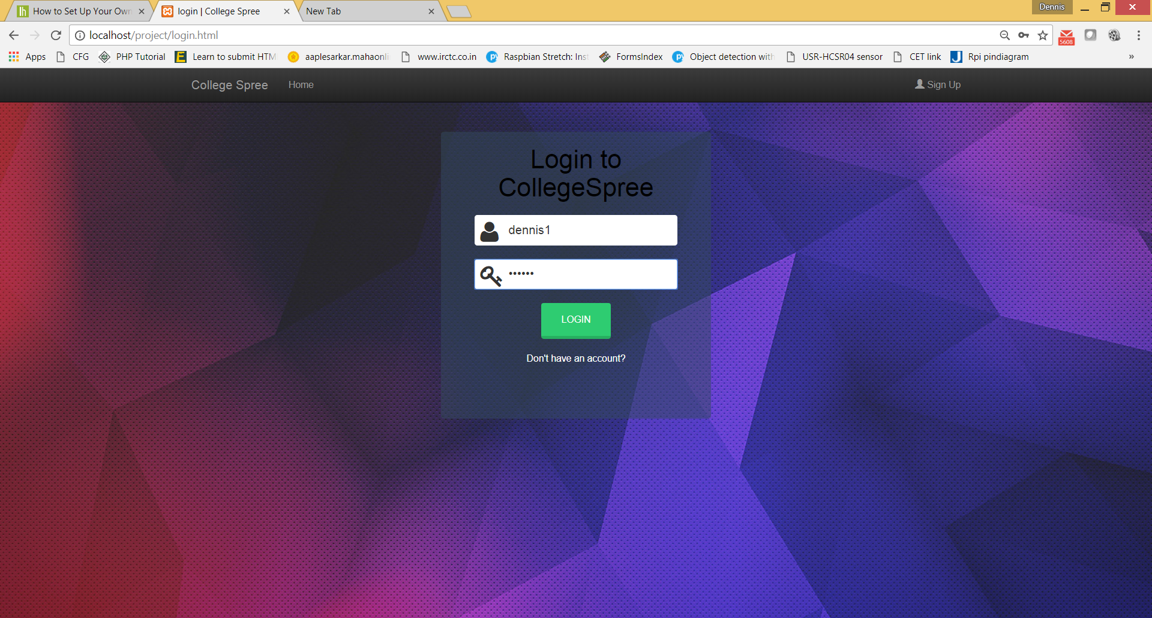

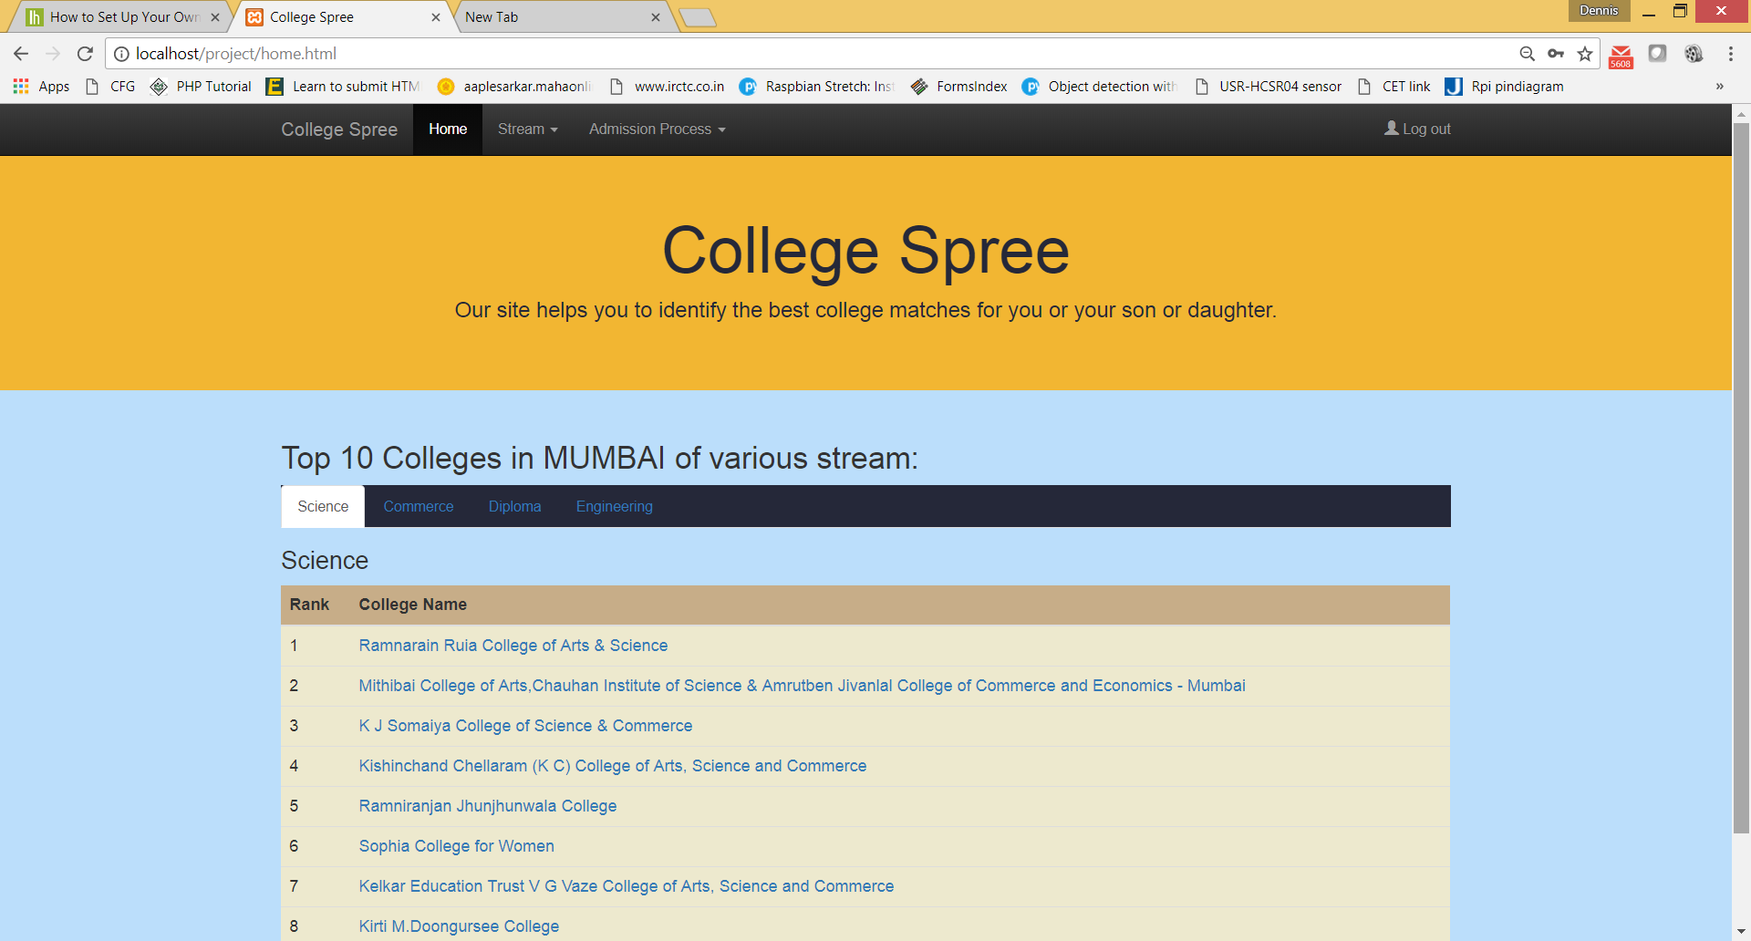

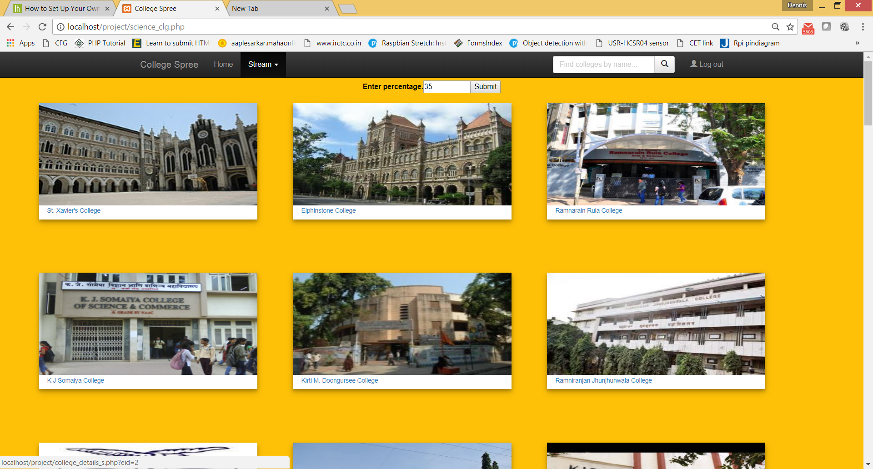

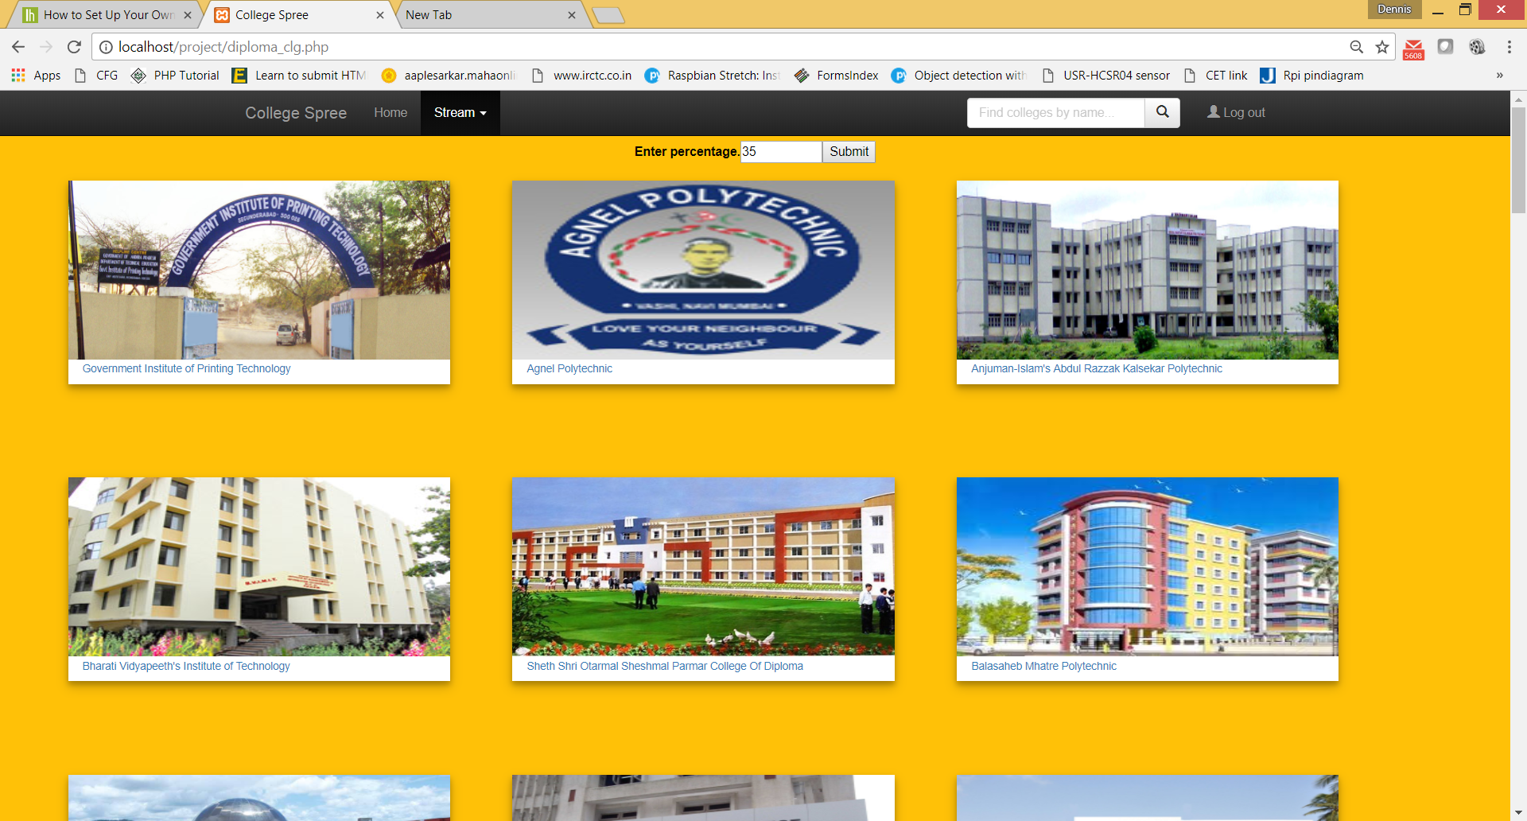

**CONCLUSION:**

In terms of aesthetic appearance we have included vibrant colors to attract the eyes of the user and also keep the UI comprehensive of visual clues to get the information. It is made such that the future tech is compatible with it and it can be easily accessed across different platforms.